

Session: 2021 – 2025

**Submitted by:**

Saqib Shehzad 2021-CS-187

**Supervised to:**

Mam Abqa Javed

Department of Computer Science

**University of Engineering and Technology**

**Lahore Pakistan**

**Operating System Lab Mid Exam**

**Question:**

Compute the Factorial using IPC (PIPE implementation).

1. Parent creates pipe

2. Forks a child

3. Parent writes into pipe (the number for Factorial)

4. Child reads from pipe and compute the Factorial for the number written by Parent and print them.

**Solution :**

* **Header Files :**

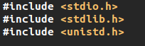

* **Factorial Function :**

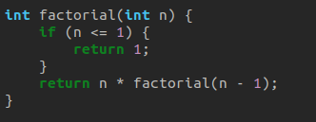

* **Main Function :**

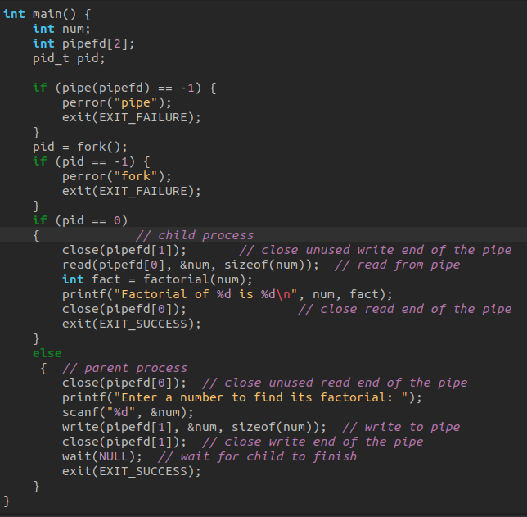

* **Output of the program :**

